Cat.7 S/FTP Duplex  Installation Cable  187311  187312 |  |   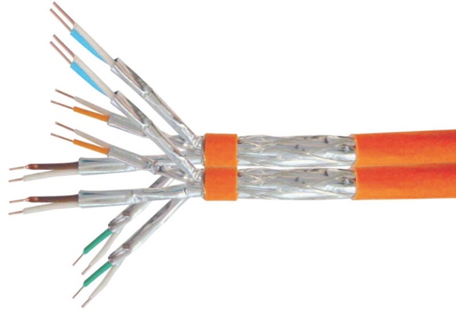
The equip® Duplex Installation Cable is made of preeminent materials and thoroughly examined to meet or surpass industrial standards defined by the EIA / TIA, ISO and EN standard bodies. The performance is guaranteed via a comprehensive test including attenuation, return loss, NEXT (Next End Crosstalk) and FEXT (Far End Crosstalk) up to 1000MHz and the hence the equip® Installation Cable serves well in the most demanding networking environments.
l Structure
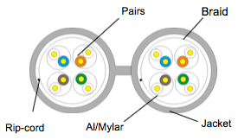
l Specification
Conductor | Material | Bare Copper
Conductor | Construction | 23AWG, 1/0.56 ± 0.05mm
Insulation | Material | Skin-foam-skin PE
Insulation | Thickness | MIN at any point: 0.15 mm / MAX AVG:0.22 mm
Insulation | Diameter | 1.330 ± 0.05mm
Insulation | Colors | Blue-White/Blue, Orange-White/Orange, Green-White/Green, Brown-White/Brown
Jacket | Material | LSZH
Jacket | Thickness | 0.55mm ± 0.05mm
Jacket | Diameter | (7.7-16.4) ± 0.5mm
Jacket | Colors | Orange (RAL2003)
Jacket | Marking | 187311: equip CAT.7 Duplex S/FTP LSOH 4PR 23AWG INSTALL CABLE ISO/IEC 11801 & ANSI/TIA-568-C.2 VERIFIED EN50575:2014 Fire Class B2ca
Jacket | Marking | 187312: equip CAT.7 Duplex S/FTP LSOH 4PR 23AWG INSTALL CABLE ISO/IEC 11801 & ANSI/TIA-568-C.2 VERIFIED EN50575:2014 Fire Class B2ca
Reaction to | Fire Classification | B2ca,s1,d1

l Electrical Properties
Electrical Characteristics | Impedance(Ω) : (1-100MHz) | 100±15Ω
Electrical Characteristics | (100-250MHz) | 100±18Ω
Electrical Characteristics | (250-600MHz) | 100±25Ω
Electrical Characteristics | Delay Skew (ns/100m) | <25
Electrical Characteristics | Velocity of Propagation (%) | 74
Electrical Characteristics | unbalanced-to-ground capacitance (pf/100m) max | 330
Electrical Characteristics | DC Resistance (Ω/100m) max | 9.38
Electrical Characteristics | DC Conductor Resistance Unbalanc (%) max | 2

l Performance

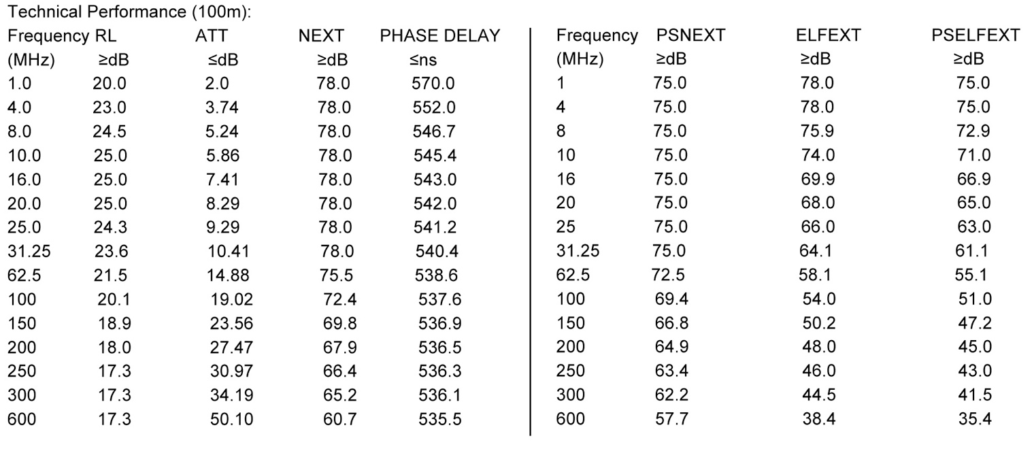
l Ordering Information
PN | EAN | Length
187311 | 4015867202449 | 500m
187312 | 4015867202456 | 1000m

